Please follow instructions carefully. The quality of your specimen is critical to the accuracy of test results.

 ***CAUTION:*** 

**The contents of the containers are POISON. KEEP OUT OF REACH OF CHILDREN.**

**If fluid is accidentally swallowed, drink 2-4 glasses of water or milk and immediately contact your**

**emergency department or poison control center.**

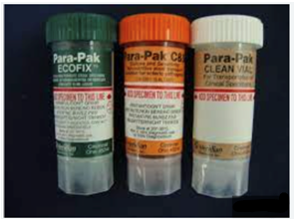**NOTE:** Do not use a laxative before collecting a stool specimen.

Use the Stool Transport System provided by your physician or the Laboratory at Logan Health Whitefish.

* **Stool Culture (Cary Blair/Orange Top)**
* **Ova and Parasites (Ecofix/Green Top)**
* **Clean Vial (White Top)**

**INSTRUCTIONS:**

1. Stool should be passed into a clean, DRY container. Use a bed pan or place a large plastic bag into a waste basket to catch specimen. You also may have been provided a plastic hat for collection. Do not let urine or water contaminate the specimen. Urinate before collecting the stool specimen, if necessary.
2. Remove the vials from inside the plastic bag. Specimens need to be put into vials within 2 hours of passing.
3. Open the vials carefully. Using the collection spoon attached to the vial cap, add enough stool until the liquid reaches the RED LINE on the vial label. DO NOT OVERFILL the vials. The clear vial has no liquid in it. Using the same technique, fill it with stool to the RED LINE.

**NOTE**: Collect stool from areas that look bloody or mucous.

1. Tighten the cap so the specimen does not leak out and shake the vial until the mixture appears well mixed.
2. **IMPORTANT**: Thoroughly label all vials with patient’s FULL NAME, DATE OF BIRTH OR SS#, and DATE/TIME OF COLLECTION. Store at refrigerator temperature until delivered to the laboratory. Return the specimen to Logan Health Whitefish Laboratory location within 24 hours of collection.

IF YOU HAVE ANY QUESTIONS, PLEASE CALL THE LABORATORY AT 406-863-3577